Guide to Use the LECC Complaint Letter

- Complete all parts highlighted in yellow in your own words or using your information.

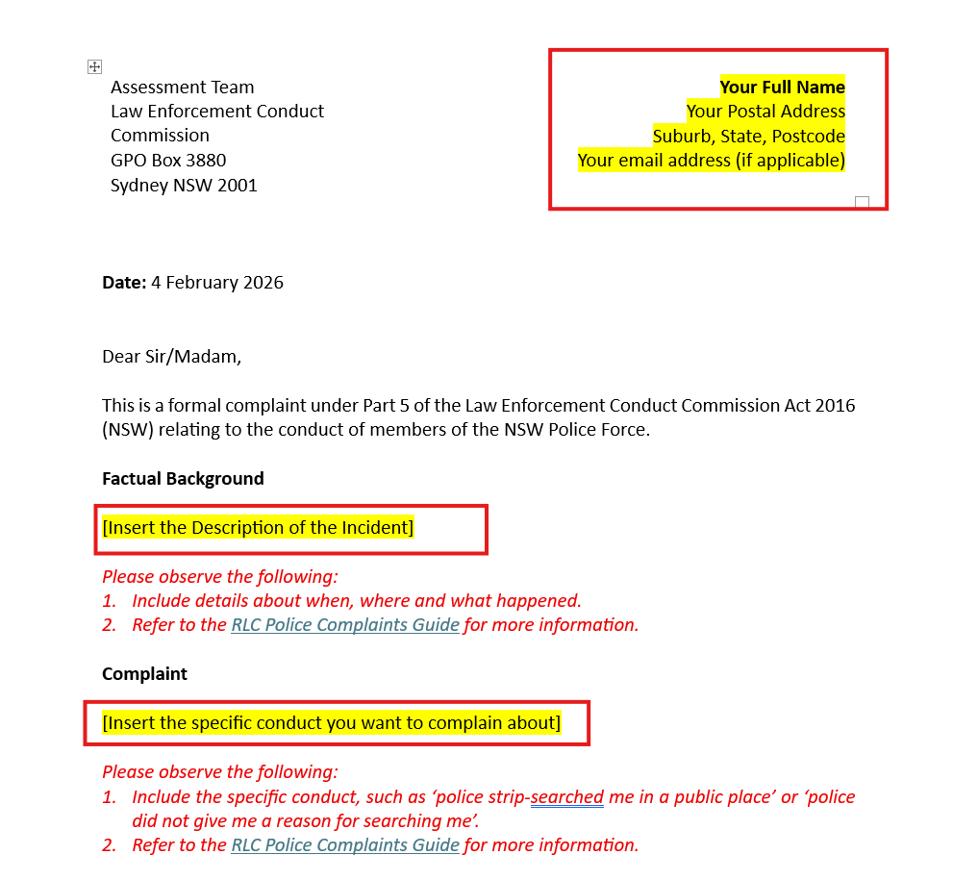

- Delete all read texts after reading the instructions

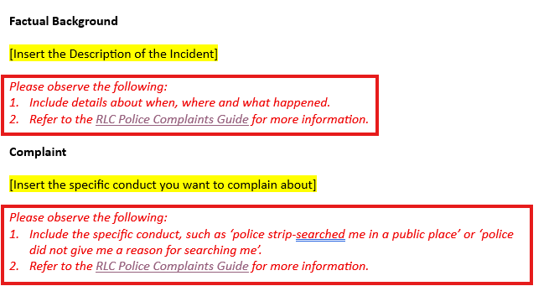

- Delete this page before preparing the letter to send to the Law Enforcement Conduct Commission.

- Email the letter to: contactus@lecc.nsw.gov.au
- Print, Sign and Post the letter to: GPO Box 3880, Sydney NSW 2001, OR Bring the letter in person to: Level 3, 111 Elizabeth Street, Sydney NSW 2000
Assessment Team  Law Enforcement Conduct Commission  GPO Box 3880  Sydney NSW 2001 | Your Full Name  Your Postal Address  Suburb, State, Postcode  Your email address (if applicable)

Date: 4 February 2026

Dear Sir/Madam,

This is a formal complaint under Part 5 of the Law Enforcement Conduct Commission Act 2016 (NSW) relating to the conduct of members of the NSW Police Force.

Factual Background

[Insert the Description of the Incident]

Please observe the following:
- Include details about when, where and what happened.
- Refer to the RLC Police Complaints Guide for more information.

Complaint

[Insert the specific conduct you want to complain about]

Please observe the following:
- Include the specific conduct, such as ‘police strip-searched me in a public place’ or ‘police did not give me a reason for searching me’.
- Refer to the RLC Police Complaints Guide for more information.

Next Steps:

[Insert details of any specific outcome you seek]

Please observe the following:
- Refer to the RLC Police Complaints Guide for more information

This complaint is made on the basis that the police officers engaged in police misconduct or maladministration as defined by s 9 and s11 of the Law Enforcement Conduct Commission Act 2016 (NSW). I request that this complaint be investigated.

Please contact me if you require any further information.

Yours faithfully
[Your Full Name]

